

Project Interim Report

On

E-Commerce Shopping Cart System (Using Core Java & OOP Concepts)
RU-100-01-00012
Object Oriented Programming with Java

SESSION: 2025-26

Submitted By Shivam Kumar
ERP: RU-25-11365

Bachelor of Technology in Computer Science & Engineering in association with Google

Under the Guidance of Mr. Ashish Shivhare

SCHOOL OF COMPUTER SCIENCE AND ENGINEERING RUNGTA INTERNATIONAL SKILLS UNIVERSITY
BHILAI, CG

(April 2026)

Certificate

This is to certify that the project titled
“Online Food Delivery System (Using Core Java & OOP Concepts)”
is a bonafide work carried out by Sobhit Kumar (Reg No.: RU-25-11437)
in partial fulfillment of the requirements for the award of the degree of
Bachelor of Technology in Computer Science & Engineering.
This project has been completed under the guidance of
Mr. Ashish Shivhare during the academic session 2025–26.
To the best of our knowledge, this work has not been submitted
elsewhere for any other degree or diploma.
-------------------------- --------------------------
Signature of Guide Signature of Student
Date: __________ Date: __________

Acknowledgement

I would like to express my sincere gratitude to my project guide
Mr. Ashish Shivhare for his valuable guidance, support, and encouragement
throughout the development of this project.
I am also thankful to the faculty members of the School of Computer Science
and Engineering for providing the necessary resources and support.
I would like to thank my friends and family for their continuous support
and motivation during the completion of this project.
Finally, I would like to thank the university for providing me the
opportunity to work on this project and enhance my practical knowledge.
Sobhit Kumar
RU-25-11437

Abstract

This project focuses on developing an E-Commerce Shopping Cart System using Core Java and Object-Oriented Programming concepts. The system allows users to add and remove products from a shopping cart, view items, and generate a final bill during checkout. Each product contains attributes such as product name, price, and quantity.

The need for this project arises from real-world online shopping platforms where users manage their purchases through carts. This system simulates similar functionality in a simplified way. It dynamically updates the total price, applies discounts and taxes, and generates a detailed bill summary.

The project demonstrates key OOP principles such as encapsulation, modularity, and abstraction. It also helps in understanding real-world business logic like billing, pricing calculations, and user interactions in e-commerce systems.

Introduction
The E-Commerce Shopping Cart System is a Java-based application designed to simulate the working of an online shopping platform. In today’s digital world, online shopping has become an essential part of daily life, and this project replicates its core functionality.
The system allows users to add products to a cart, remove them, and view the current cart status. It automatically calculates the total amount based on product price and quantity. Additionally, it applies discounts and taxes to generate the final payable amount.
This project is built using Object-Oriented Programming concepts, where different classes such as Product and Cart are used to organize data and operations efficiently. It ensures better code structure, reusability, and maintainability.
Objectives
- Understand and apply OOP concepts (classes, objects, encapsulation)
- Simulate real-world e-commerce shopping logic
- Perform dynamic calculations (total, discount, tax)
- Reduce manual calculation errors
- Improve programming and problem-solving skills

Scope
This project is suitable for small-scale e-commerce simulations and educational purposes. It can be extended in the future by adding database integration, user authentication, and graphical user interfaces.

System Requirements
Hardware: Computer with minimum 4GB RAM
Software: Java JDK, IDE (VS Code / Eclipse)

Methodology
The system works in a step-by-step manner:
- User adds products to the cart
- System stores product details in an array/list
- User can remove products using product ID
- The system continuously updates the total amount
- Discount and tax are applied during checkout
- Final bill is generated displaying all details

Flowchart


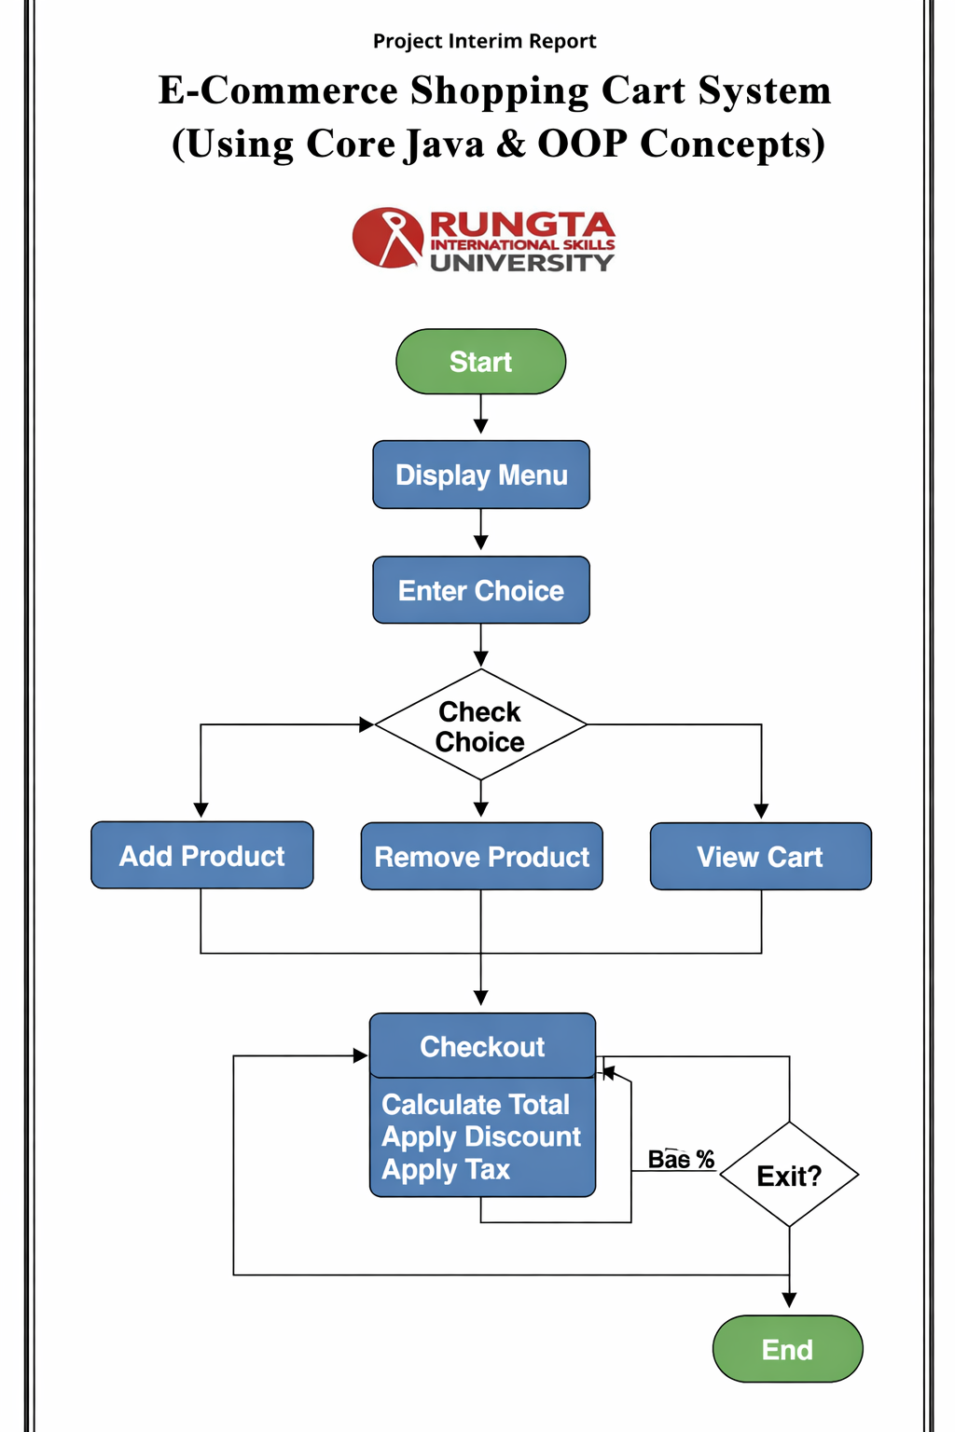

Implementation

The project is implemented using three main classes:

FoodItem Class
Stores item name and price.

Restaurant Class
Stores restaurant name and menu items. It also displays menu.

Order Class
Handles item selection, quantity, billing, and order summary.

The system uses arrays to store items and quantities as per requirement.

Implementation

The E-Commerce Shopping Cart System is implemented using Object-Oriented Programming principles with mainly three classes.

Product Class:
This class is used to store details of each product such as product ID, product name, price, and quantity. It provides methods to access and display product information. It acts as the basic unit of the system.

Cart Class:

This class manages the shopping cart. It stores a collection of products using an ArrayList. It includes methods to:

Add products to the cart

Remove products from the cart

Display all items in the cart

Calculate the total price

This class ensures that all cart operations are handled efficiently.

• Main Class:

This class controls the overall flow of the program. It interacts with the user through a menu-driven system. It includes options to:

Add product

Remove product

View cart

Checkout

During checkout, it calculates the total amount, applies discount and tax, and displays the final bill.

Input \ Output

The following outputs are obtained after executing the program in the terminal:

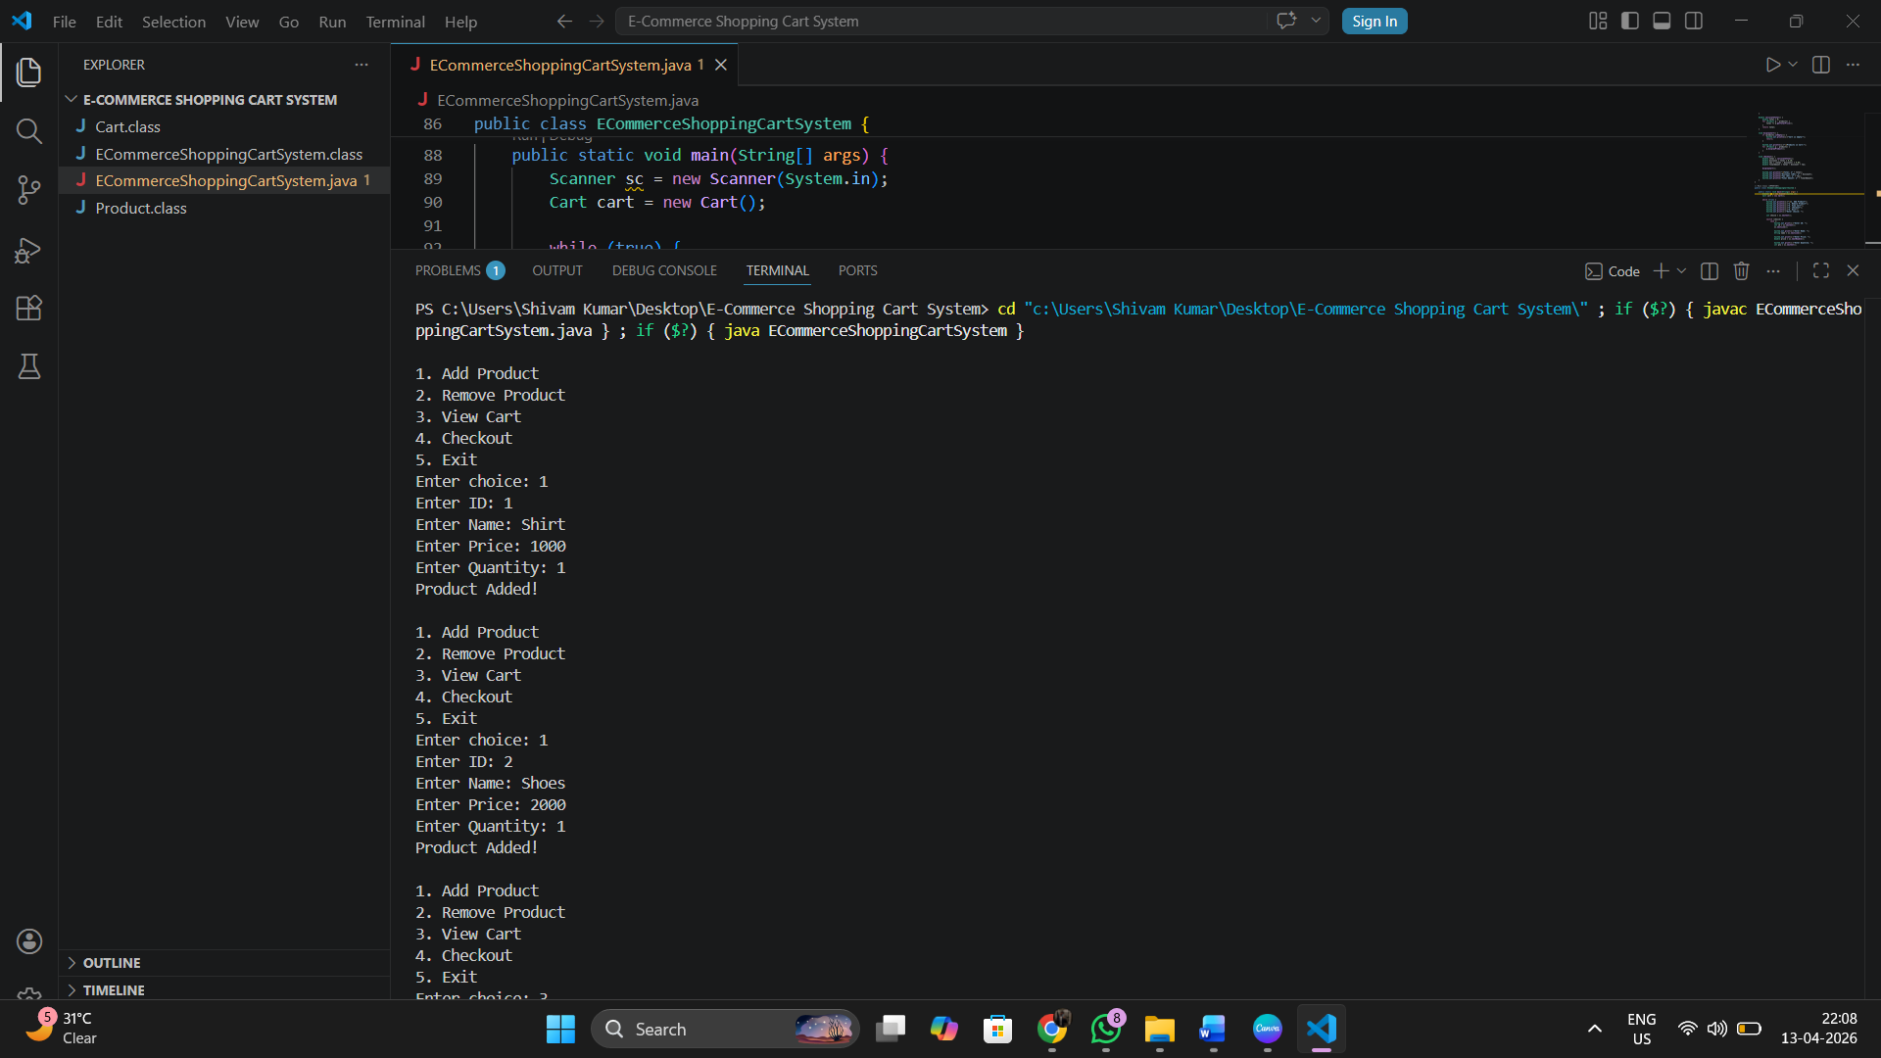

Figure 1: Sample Run 1

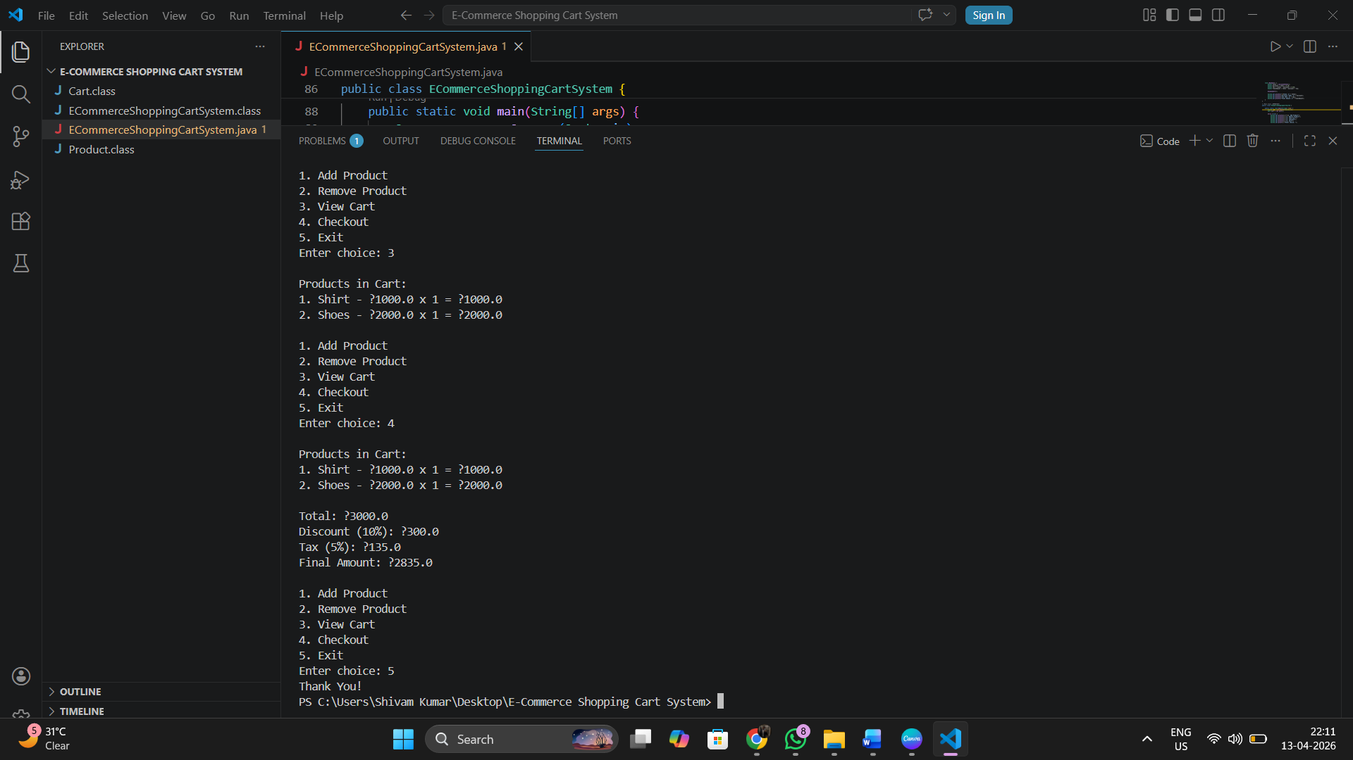

Figure 2: Sample Run 2

Future Enhancements

The project can be further improved with the following features:–

• Add multiple product categories and product search functionality
• Implement user login and authentication system
• Integrate database (MySQL/SQLite) for storing cart and user data
• Add online payment options (UPI, Card, Net Banking)
• Provide discount coupons and promotional offers
• Develop a graphical user interface (GUI) using Java Swing or Web Application
• Add order history and tracking system.

Gantt Chart
1. Planning & Structure
A Gantt chart helps to divide the project into different tasks such as planning, designing, coding, and testing. It also helps in setting timelines for each phase of the project. Even if the project is already developed, modifying or improving it still requires proper planning.

2. Time Management

It shows:
• When each task starts
• When it should finish

This helps in proper time management, avoiding delays and last-minute work pressure.

Conclusion
T The project successfully demonstrates the use of Object-Oriented Programming concepts in Java. It provides a simple and efficient system for managing shopping cart operations, including adding and removing products, calculating total cost, and generating the final bill with discount and tax.he project successfully demonstrates the use of Object-Oriented Programming concepts in Java. It provides a simple and efficient system for managing food orders and billing.

The system is user-friendly and follows a modular approach, making it easy to understand and maintain. This project also helps in understanding real-world e-commerce logic and improves programming skills.

References Book Format:

[1] H. Schildt, Java: The Complete Reference, 11th ed. New York: McGraw-Hill, 2018.

Example:
[1] H. Schildt, *Java: The Complete Reference*, 11th ed. New York: McGraw-Hill, 2018.

Website Format:
[2] Author (if any), "Title of page," Website Name. [Online]. Available: URL

Example:
[2] Oracle, "Java Documentation," Oracle. [Online]. Available: https://docs.oracle.com

Conference Paper
Format:
[3] Author(s), "Paper title," in Proc. Conference Name, year, pp.
Example:
[3] S. Kumar, "AI in Education," in Proc. IEEE Conf. on AI, 2021, pp. 120-125.

Journal Article
Format:
[4] Author(s), "Title of paper," Journal Name, vol., no., pp., year.
Example:
[4] A. Sharma and R. Gupta, "Machine Learning Techniques," International Journal of AI, vol. 5,
no. 2, pp. 45-50, 2020.

